Resize the document to fit your screen using the zoom function on the menu above.
Core considerations |  |  |  |  |  |  |  |  |  |  |  |  |  |  |  |  |  |  |  | 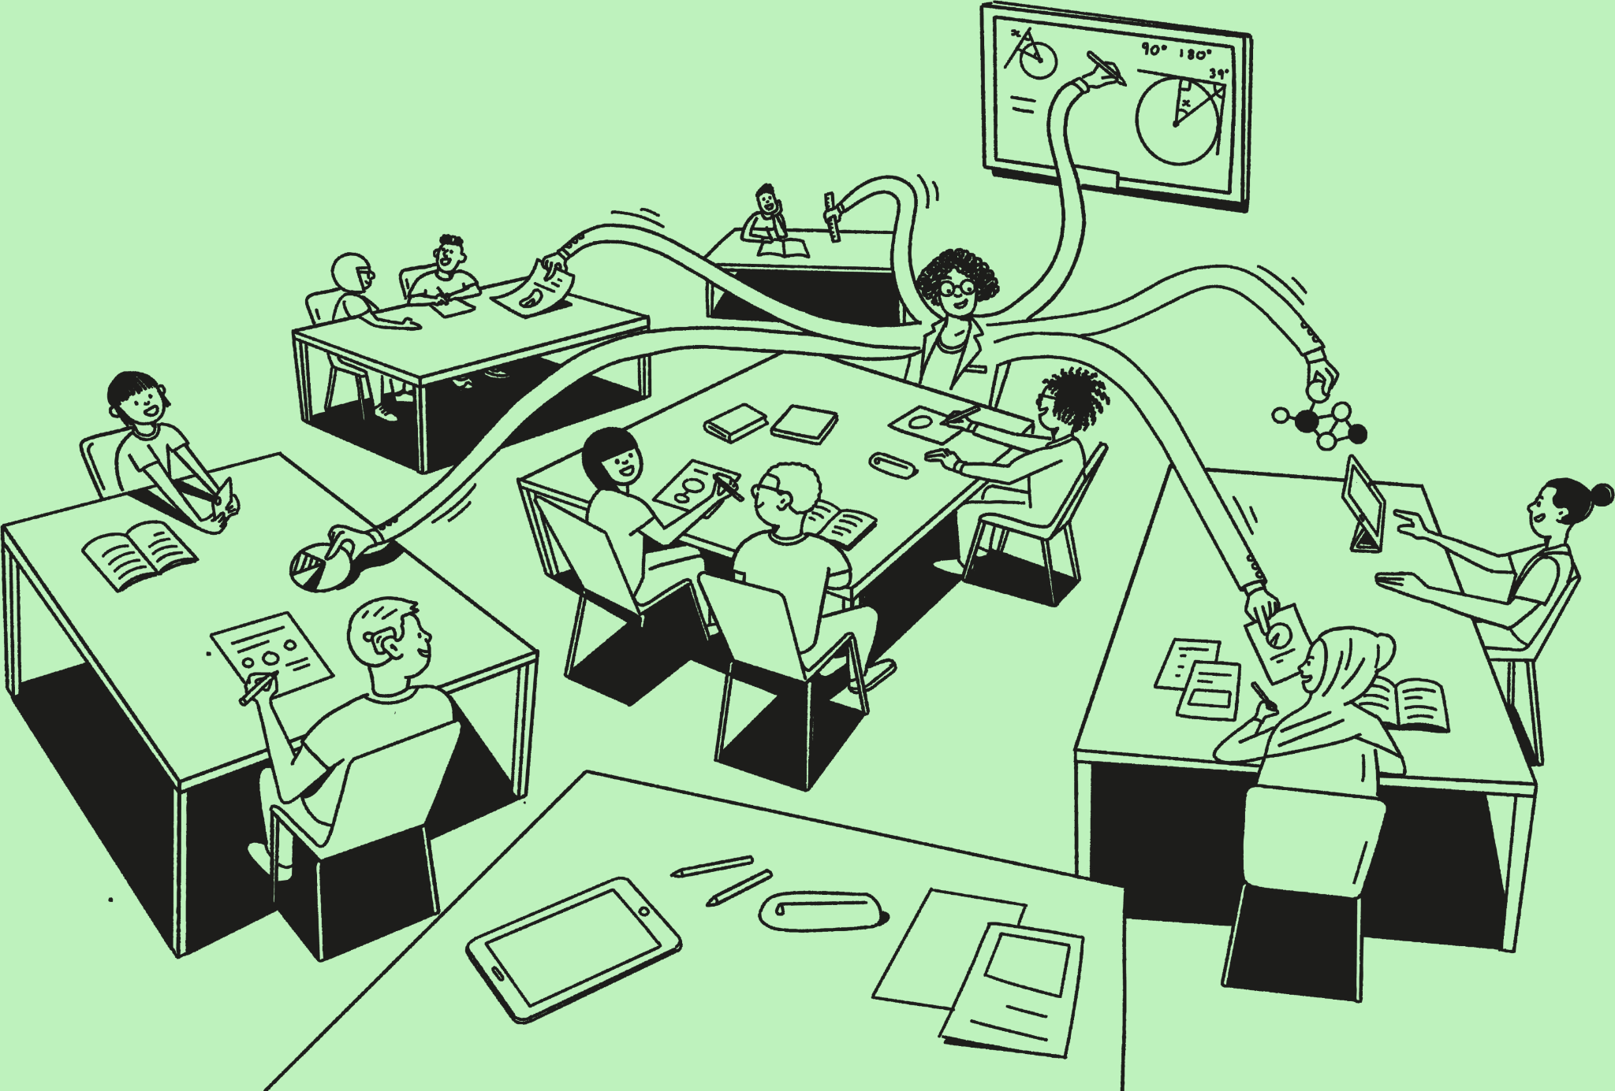
There are a number of aspects to Oak’s lessons which need to be considered to ensure pupils and teachers are safe and our moral and legal responsibilities are upheld. These can be categorised into the following areas:

 |  |  |  |  |  | 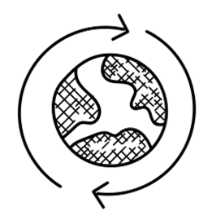 |  |  |  |  |  |  |  |  |  |  |  |  |  |  |  |  |  | 
accessibility |  |  |  |  |  | diversity |  |  |  |  |  | safety |  |  |  |  |  | safeguarding |  |  |  |  |  | content guidance

Accessibility
Lesson content should be created and designed to be accessible to all teachers and pupils. For pupils with SEND, it is vital to note that good teaching for pupils with SEND is good teaching for all. Oak’s lesson design and templates have considered aspects of this already and measures include:

- Use of a Sans Serif font.

- Left-aligned text (in most instances).

- Use of bold for keyword emphasis (rather than underline or italicise).

- Captioning in videos.

- Signing in videos.

- Transcripts of videos.

- Slide colour, font size and colour informed by sector experts.

- Use a strong contrast between text and background.

To ensure we adhere to best practice, the following Quality Standards have been identified:

- Lesson content must be developed in order to enable the Web Content Accessibility Guidelines v2.1 AA standard to be met.

- Lesson content is created and designed to be accessible to all teachers and pupils.

- Colour contrast is sufficient, with a text to background colour ratio of 4.5: 1 (this has been checked for you and colour choices built into templates)
When considering the colour choices in your slide decks, it is advised that you do not use coloured backgrounds. This ensures a strong colour contrast.
✔ Example  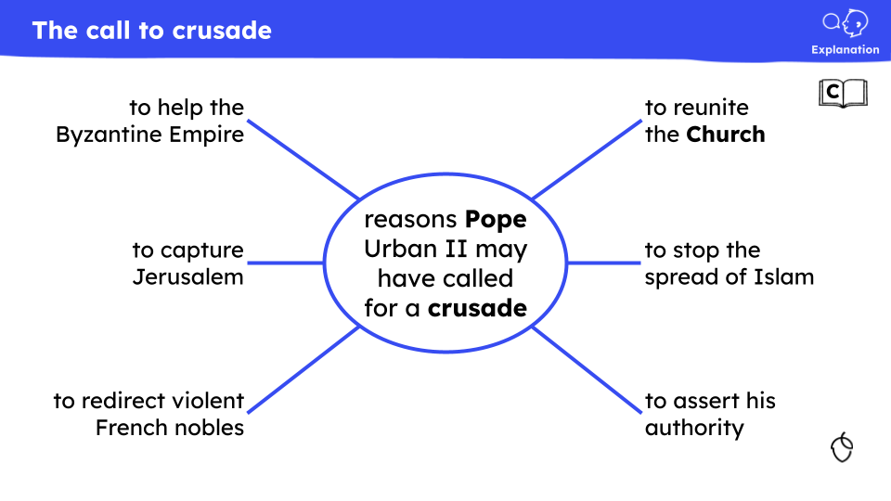 |  |  |  |  |  |  |  |  |  |  |  |  |  |  | ✘ Non-example  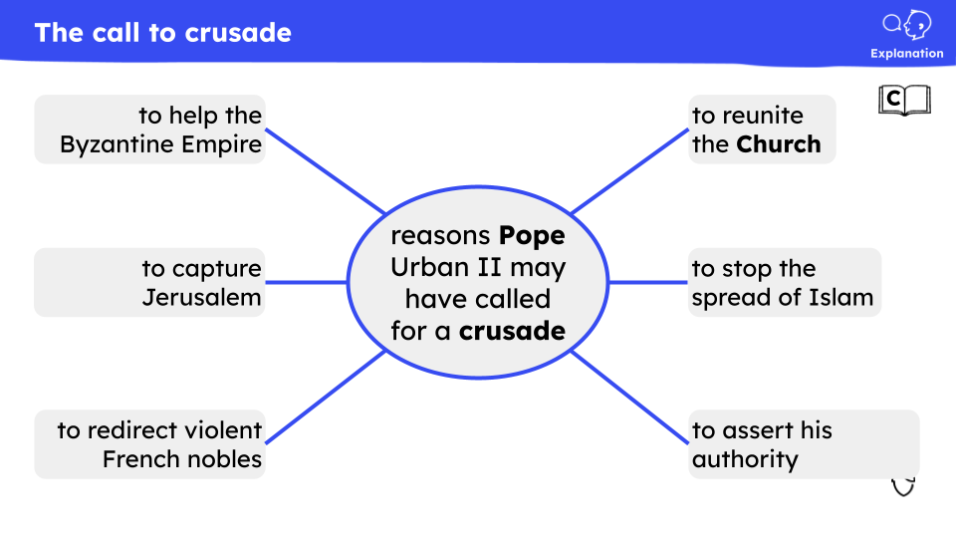

Scaffolding
The Education Endowment Fund (2023) defines scaffolding as ‘a metaphor for temporary support that is removed when it is no longer required’, providing ‘enough support so that pupils can successfully complete tasks that they could not yet do independently’.
Independent practice is critical but if pupils are not ready, they will not be successful. Responsibility for scaffolding to support pupils does not however just fall to how we craft practice tasks. Our explanations and the judicious use of checks for understanding and precise feedback also have a role to play. Furthermore, we also need to think about scaffolding as something with multiple dimensions: within a learning cycle, across a whole lesson and developing over a unit and key stage.
Many of the decisions of when and how to use scaffolding fall to the class teacher who will need to adapt their lessons for their pupils. However, we have a number of strategies and tools we can use to support pupils towards independence in the design of our lessons.
The EEF categorise scaffolding into three areas that we can draw on in the development of Oak lessons (adapted from EEF five a day principle):
- Scaffolding should be used to ensure all pupils can access the learning.
Type of scaffolding |  |  |  |  |  |  |  |  |  | Description |  |  |  |  |  |  |  |  |  | Example approaches
Visual |  |  |  |  |  |  |  |  |  | support for pupils to guide them towards success |  |  |  |  |  |  |  |  |  | - supportive criteria for success  - model examples  - images to support vocabulary teaching
Verbal |  |  |  |  |  |  |  |  |  | additional verbal instruction which addresses misconceptions and vocalises metacognitive thought processes |  |  |  |  |  |  |  |  |  | - focused discussion opportunities metacognitive narratives  - modelling and demonstration
Written |  |  |  |  |  |  |  |  |  | structures which help support task outcomes |  |  |  |  |  |  |  |  |  | - word banks  - writing frames  - sentence starters  - partially completed examples
✔ Examples  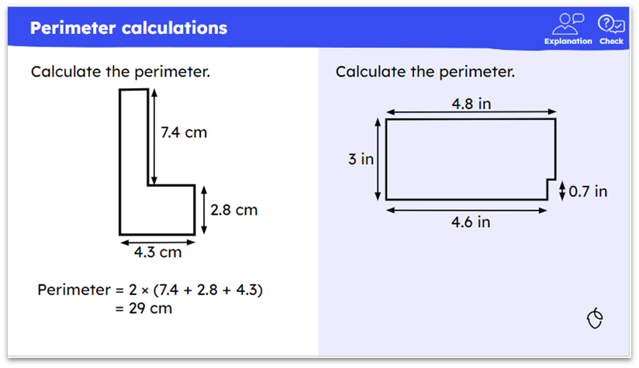  KS3 maths |  |  |  |  |  |  |  |  |  |  |  |  |  |  | 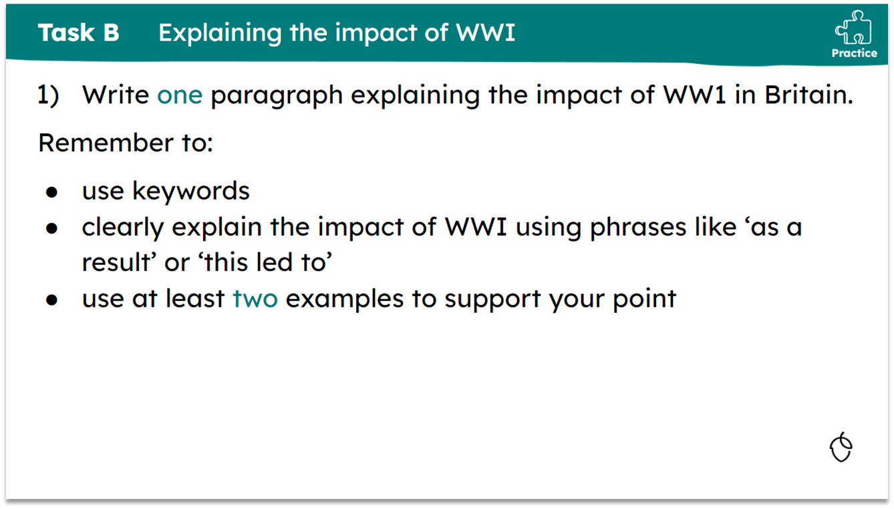  KS3 history
 |  |  |  |  |  |  |  |  |  |  |  |  |  |  | Scaffolding is explored in further detail in The Library (available Sept 2024)

🆕Diversity
Updated November 2024
Diversity is one of our Curriculum Principles and enacting this principle throughout our curriculum in our content is a priority.  Our teachers should be as positively diverse as the communities we serve. Where a teacher is teaching about an issue beyond their personal experience or identity, wherever possible, they should seek out the guidance of those with more direct personal experience. A check to make sure the issue is being positively portrayed and social and cultural references are suitable and sensitivity will likely improve the quality of the lesson.  One of the tools we have to enact and promote diversity in our lesson components is inclusive language. Inclusive language is the way that we use words or expressions to respect and acknowledge the diversity of people, ensuring that everyone feels valued.  Without carefully reflecting on our language choices, we run the risk of reinforcing negative stereotypes, power imbalances and societal injustices. Inclusive language, therefore, avoids terms that might exclude or discriminate against groups of people.  Images also play a crucial role in promoting and normalising diversity. In the classroom diverse imagery provides representation, which in turn, can help to foster a sense of belonging. Images can be powerful in challenging stereotypes by presenting a wide range of individuals in various roles and contexts, helping pupils to understand the multifaceted nature of identity.  Our Oak characters are another way in which we can show representation of different groups of people. You can find out more about our characters here. On this slide you will find the accurate pronunciation of the characters and some information about them. It is important that you consider who you are using in your lessons and why, with specific consideration given to avoiding perpetuating any stereotypes. |  |  |  |  |  |  |  |  |  |  |  |  |  |  | 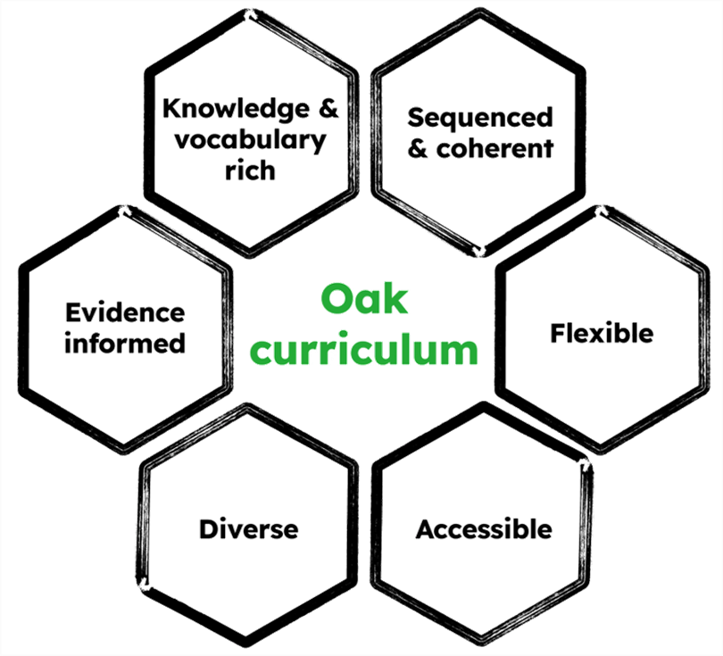
The Quality Standards below relate to the enactment of Diversity in Oak lessons:
- When creating personas in a lesson, only the approved Oak characters are used.

- We vary the use of Oak characters across lessons and units.

- All names, including the names of the Oak characters, are pronounced accurately.

- Place names are pronounced accurately.

✔ Example  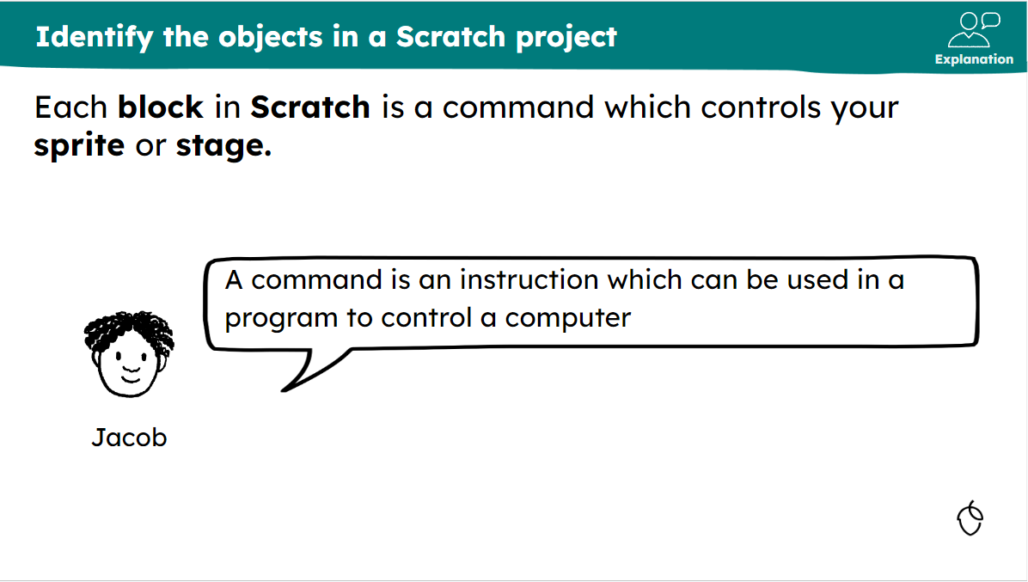  Oak created |  |  |  |  |  |  |  |  |  |  |  |  |  |  | ✘ Non-example  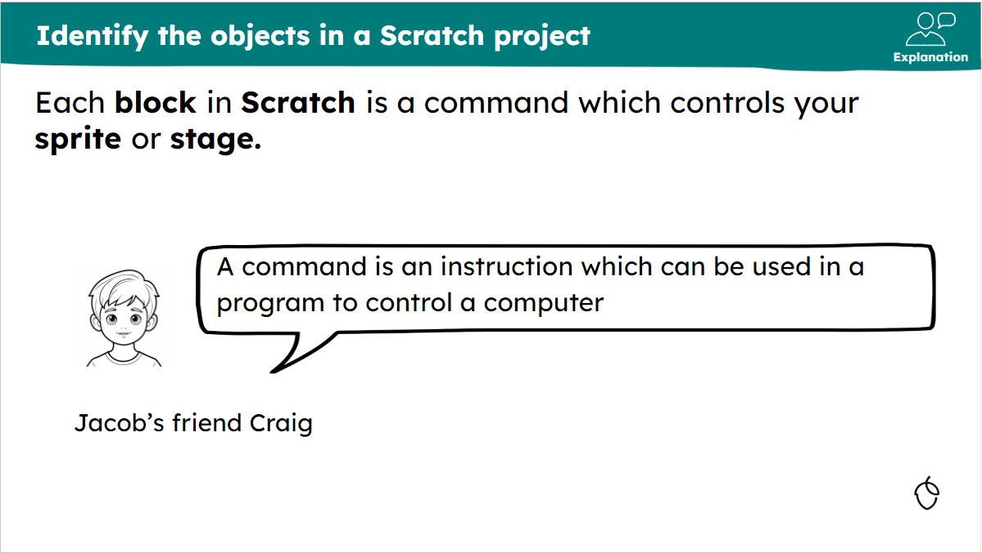  Oak created
- Images are culturally accurate, promote diversity and avoid stereotypes.
✔ Example  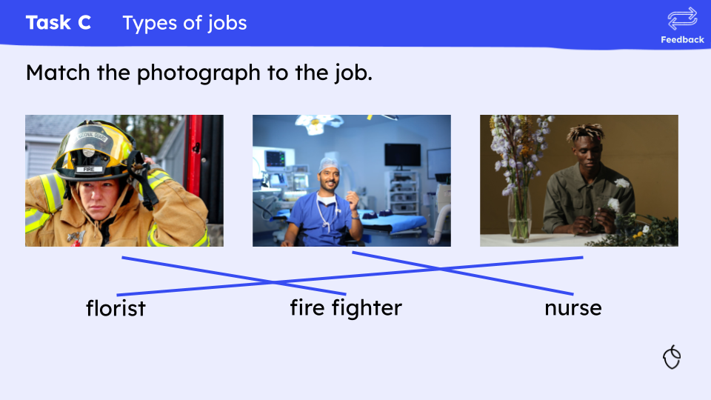  Oak created  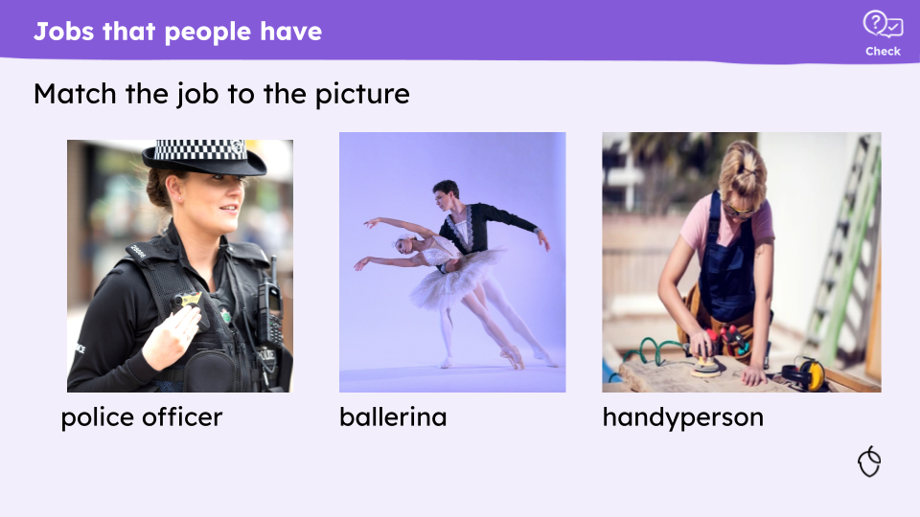  Oak created  In this example, image selection helps to promote diversity and avoid stereotypes.  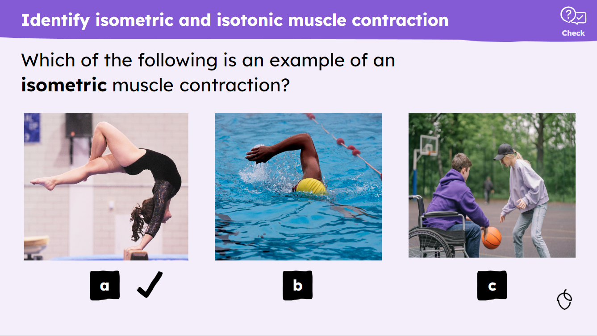  Oak created  In this example, image selection celebrates diversity, as well as showing a more stereotypical female gymnast. Including a stereotypical image is acceptable, providing that balance is provided across a lesson or unit. |  |  |  |  |  |  |  |  |  |  |  |  |  |  | ✘ Non-example  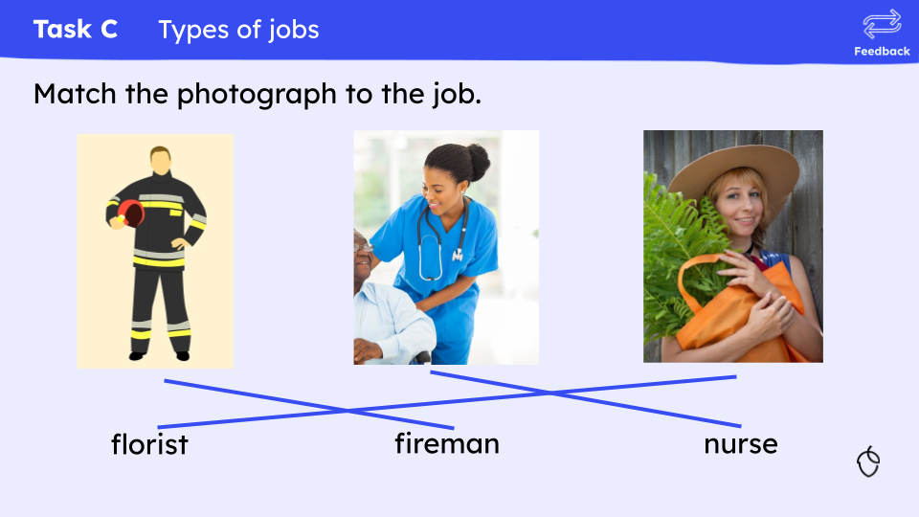  Oak created  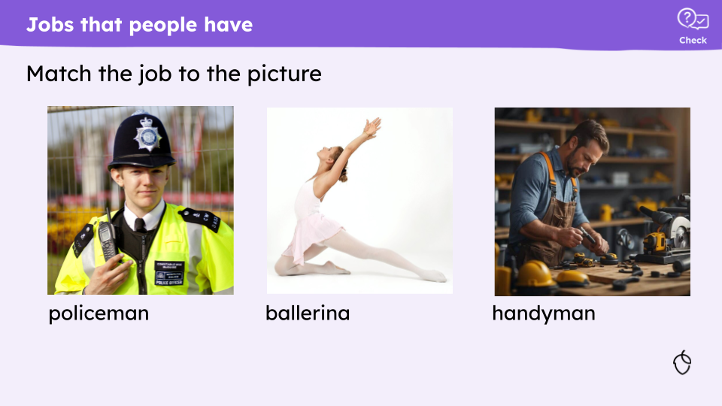  Oak created  In this non example, image selection reinforces stereotypes.
- Inclusive language choices are informed by sector experts and are based on reputable and neutral sources.

- We use the most appropriate language for describing the characteristics of a person, at the time of creation.

- Inclusivity underpins our language choices. Language that excludes and ‘others’ people is avoided.

- Language is positive and empowering, rather than language that can be demeaning or derogatory.

- Language does not make generalisations about groups of people.

- We only refer to people’s protected characteristics if it is relevant to the information we are communicating.
✔ Example  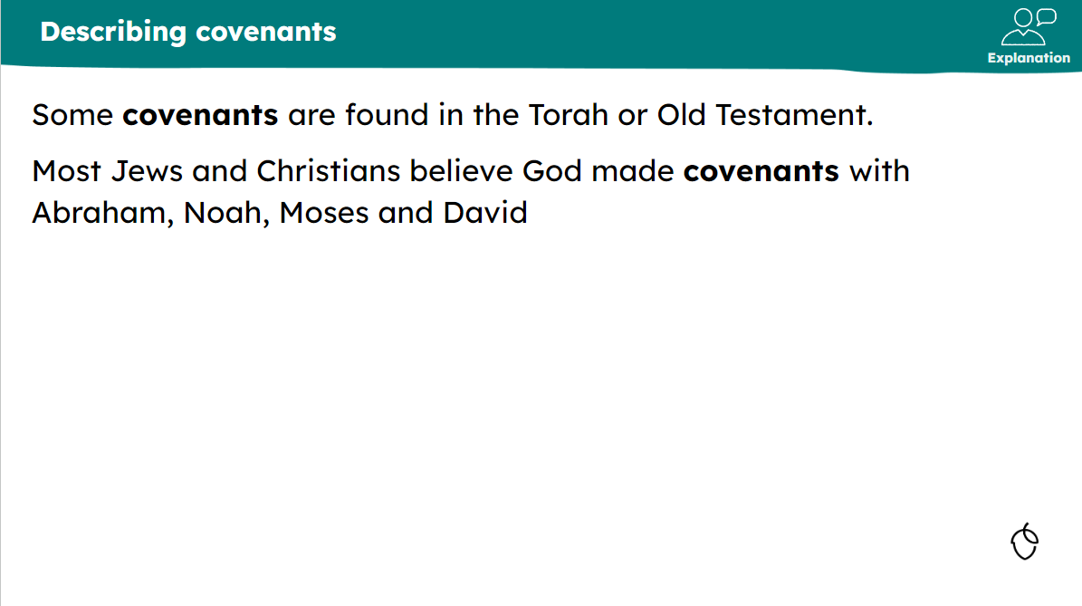  Oak created  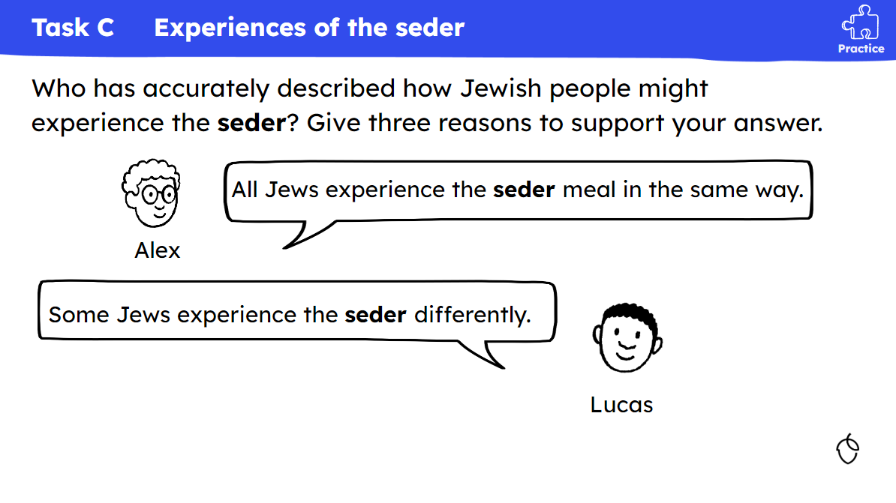  Oak created  This KS2 slide is a great example of a practice task that gives the teacher the opportunity to focus on how language such as ‘all’ can result in generalisations about groups of people.  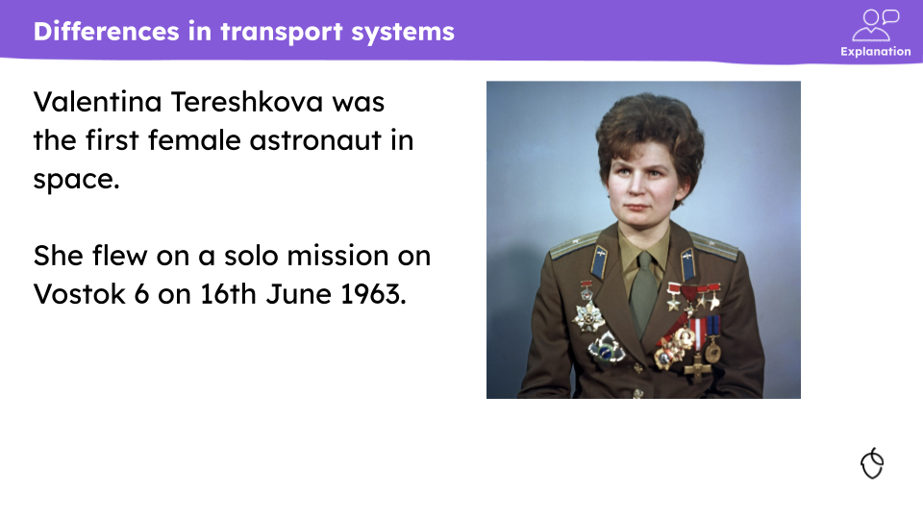  Oak created  In this example, the fact that Tereshkova was female is relevant to the knowledge. |  |  |  |  |  |  |  |  |  |  |  |  |  |  | ✘ Non-example  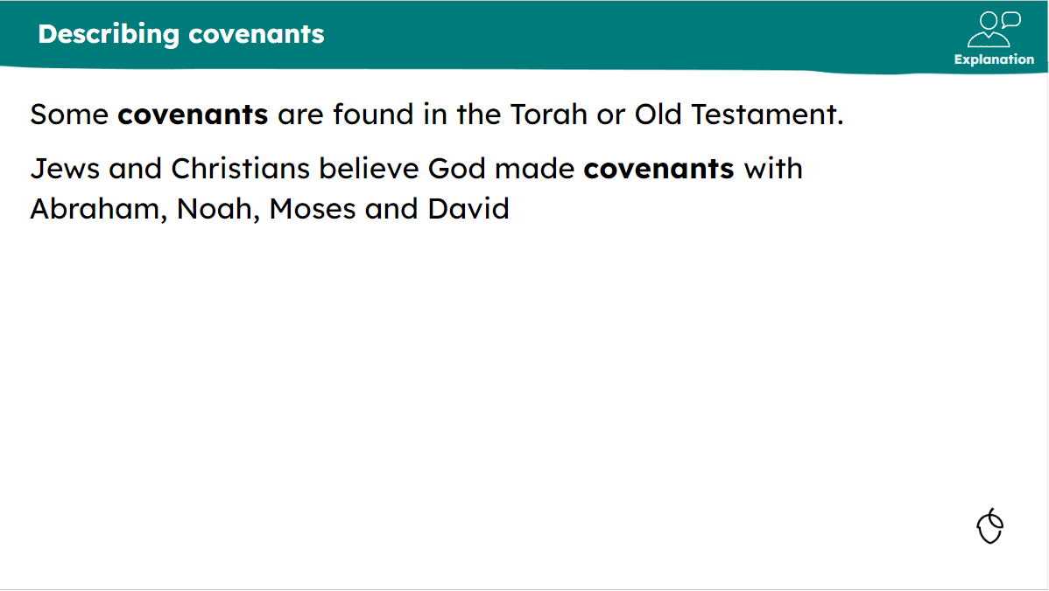  Oak created  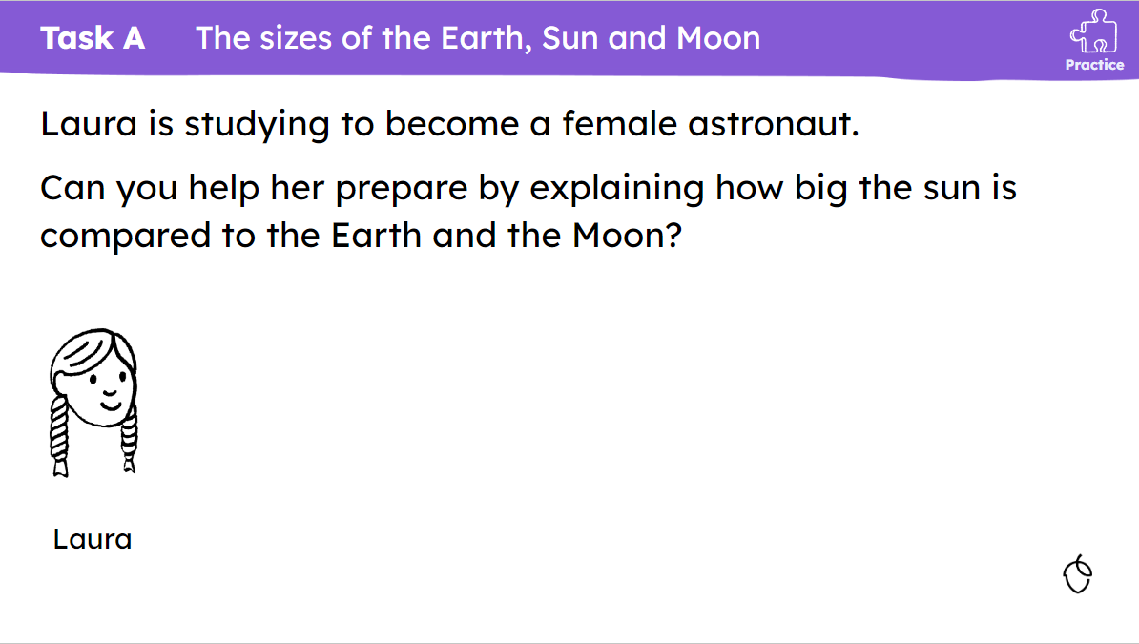  Oak created  This is a non example because the word ‘female’ here is not relevant to her becoming an astronaut.
- Non gendered language is used where possible.
✔ Example  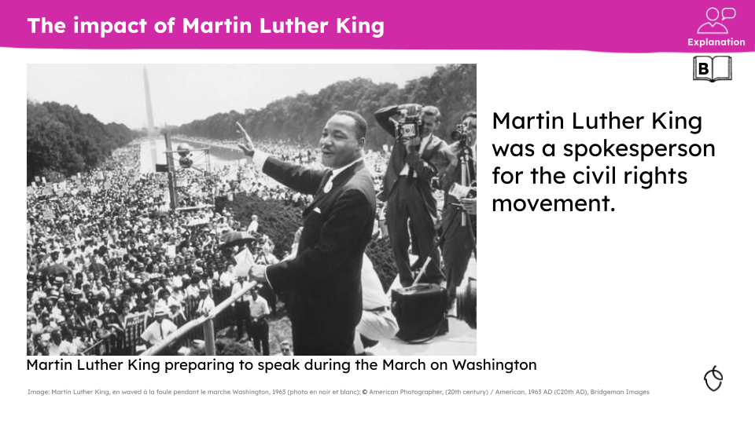  Oak created  In this example, spokesperson is non gendered.    Oak created  In this example, police officer and handyperson is non-gendered. |  |  |  |  |  |  |  |  |  |  |  |  |  |  | ✘ Non-example  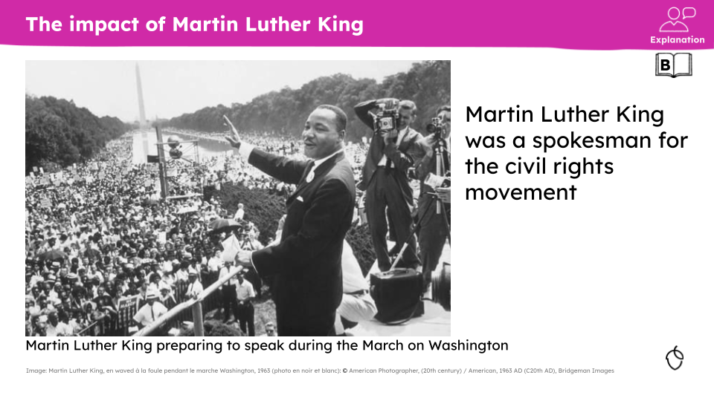  Oak created  In this non example, spokesman is gendered.    Oak created  In this non-example, policeman and handyman are gendered.
- Language relating to identity should be consistent, accurate and precise.

- When writing about nationality, we are as specific as possible.

- When we write about a place, we use the name in current usage.
✔ Example  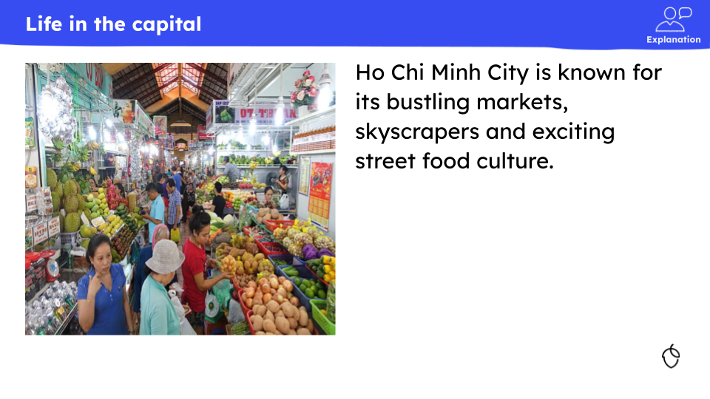  Oak created  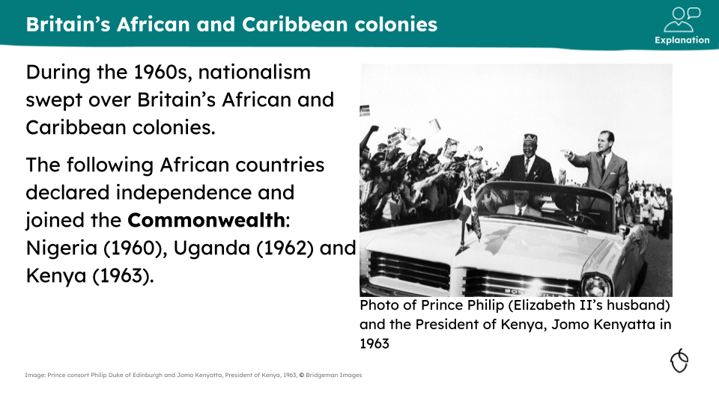  Oak created  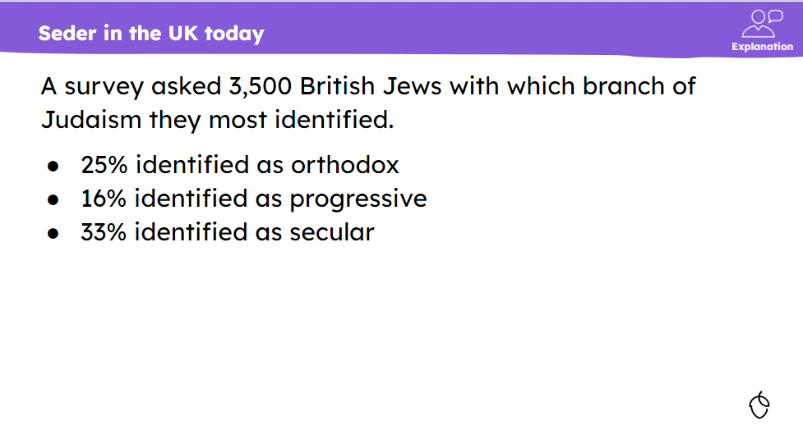  Oak created |  |  |  |  |  |  |  |  |  |  |  |  |  |  | ✘ Non-example  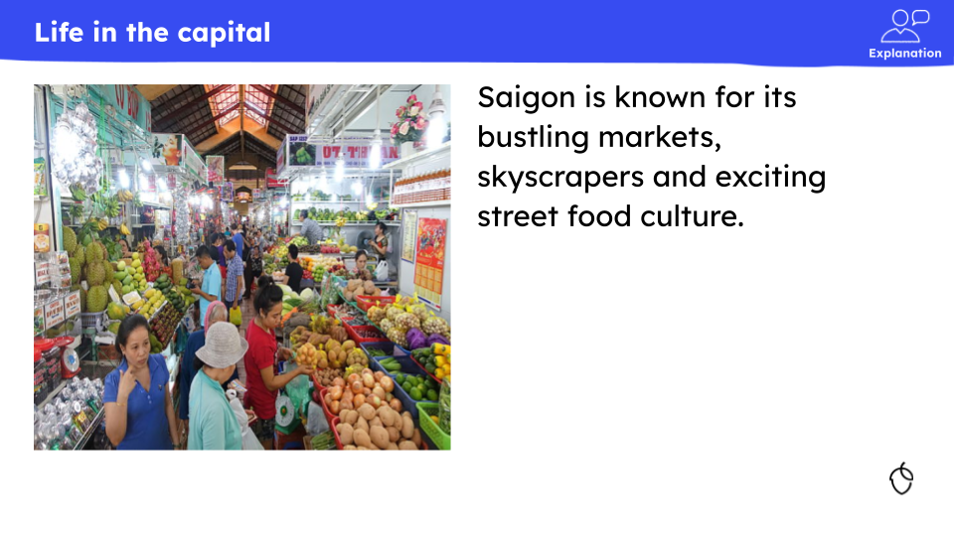  Oak created  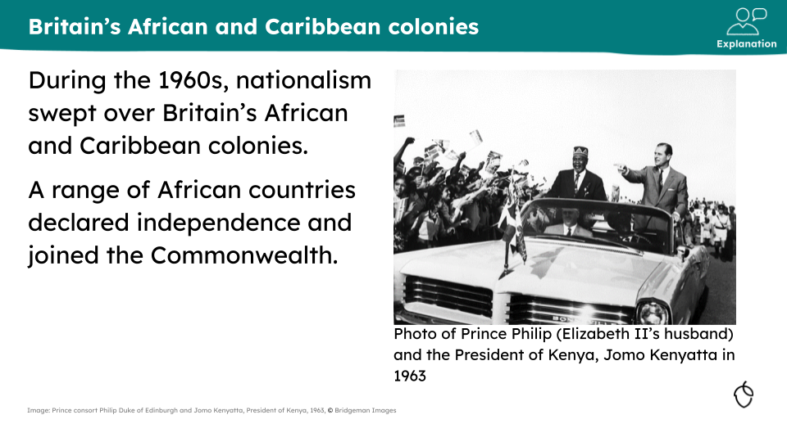  Oak created  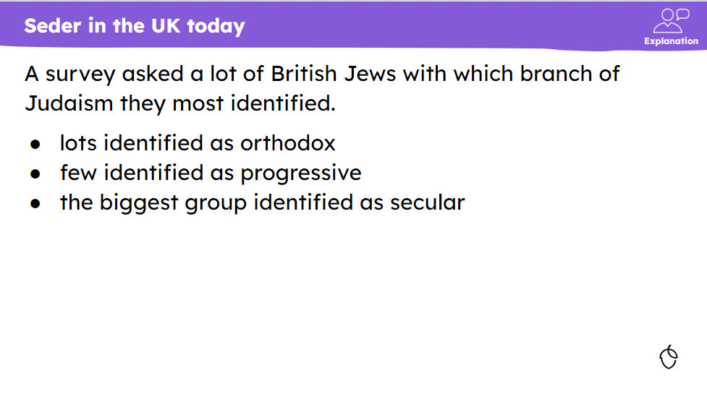  Oak created

Safety
It is important that the safeguarding of pupils is considered if an activity within the lesson has the potential to be dangerous and we must ensure that, at all times, all content is age appropriate and must model safe behaviour.

- All health and safety considerations have been identified and addressed.

- Practical activities, demonstrations and modelling follow and portray health and safety best practice.

- Safe behaviour is modelled.
✔ Examples  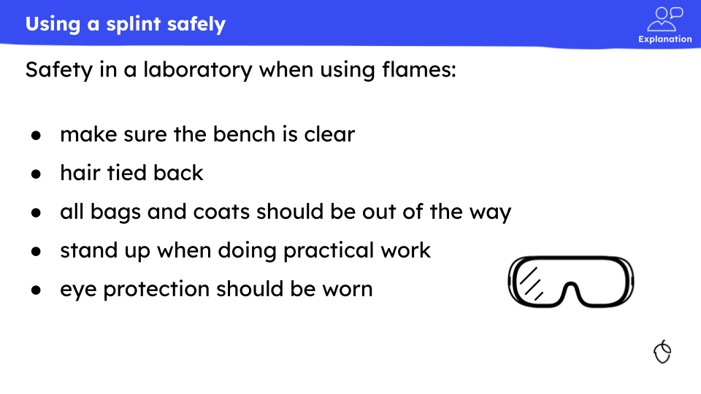  KS3 science |  |  |  |  |  |  |  |  |  | 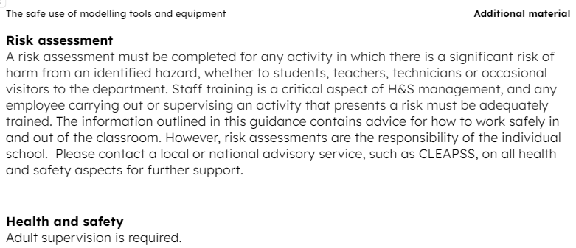

Safeguarding
It is important that the safeguarding of pupils is considered. For example, whether the lesson could bring up any challenging emotions or whether an activity within the lesson has the potential to be dangerous. Teachers should execute the same safeguarding principles and judgement that apply in face-to-face teaching and align with government guidelines. Lesson content should always be age-appropriate. For example, content from a PG film is not suitable for EYFS and KS1-2 lessons but would be suitable for KS3 and beyond. Common Sense Media rates movies, TV shows, books and more. It is also important to note that the age of pupils can vary significantly within a year group, and therefore references to age-restricted content such as social media sites or alcohol are not appropriate unless essential to the subject of the lesson.

- Appropriate safeguarding considerations have been applied to the lesson.

- All content should be free from third party links. No URLs or other links to external websites or software should be included within lessons, as changes to this content and its security will be out of Oak’s control and therefore present a safeguarding risk.

- Where lesson content meets Oak’s safeguarding criteria for challenging content, it may only be used when it is essential to the lesson, and suitable content warnings have been included where appropriate.

- All content is age appropriate.

- All imagery is age and subject appropriate
Oak characters are available on the secondary template deck. Oak lesson design elements and templates - September 2023

Most of these characters are smiling but there are circumstances in which it would be inappropriate for them to have this expression. As such, a few of the characters have been created to have expressions more appropriate for challenging lesson content.

✔ Examples  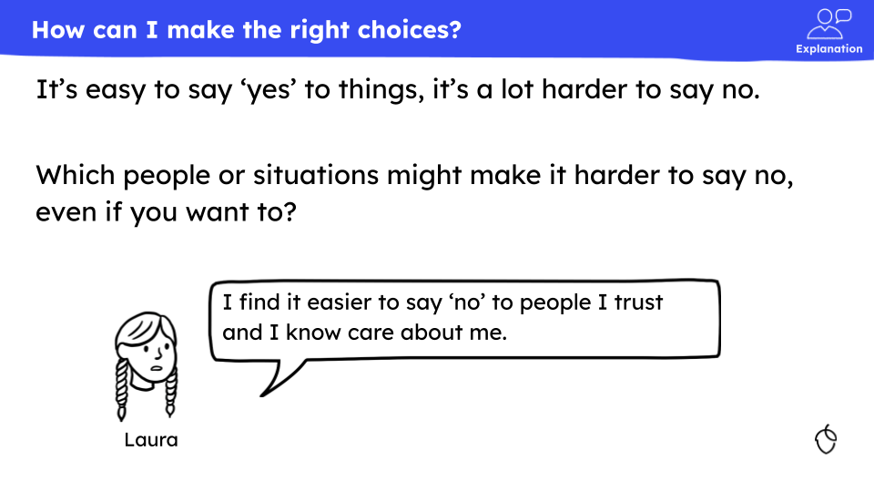  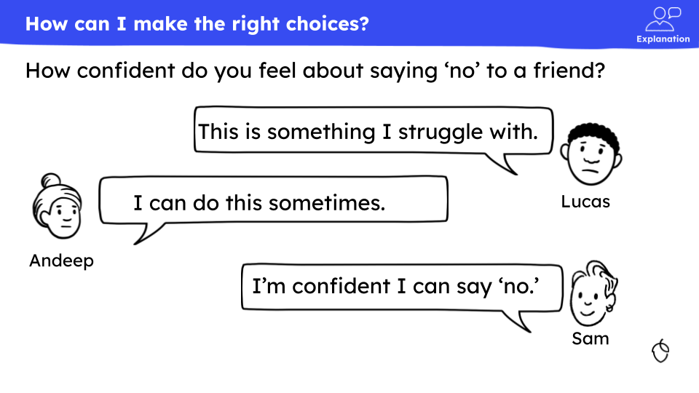 |  |  |  |  |  |  |  |  |  |  |  |  |  |  | ✘ Non-example  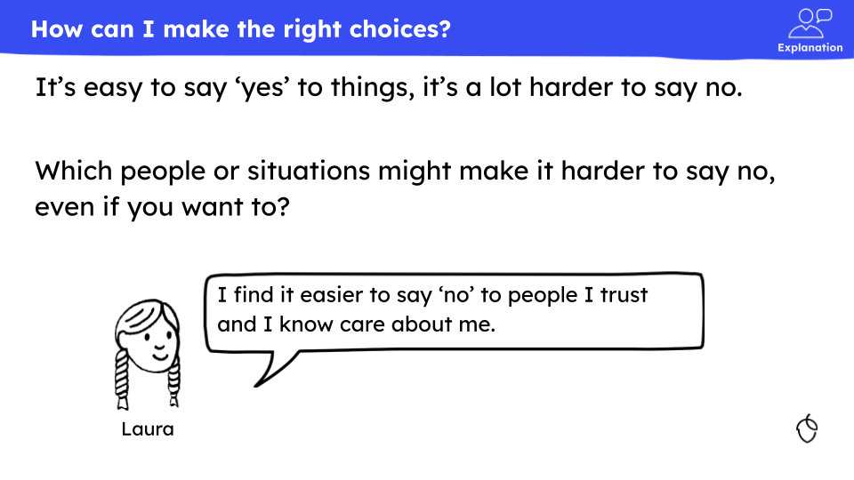  Oak created  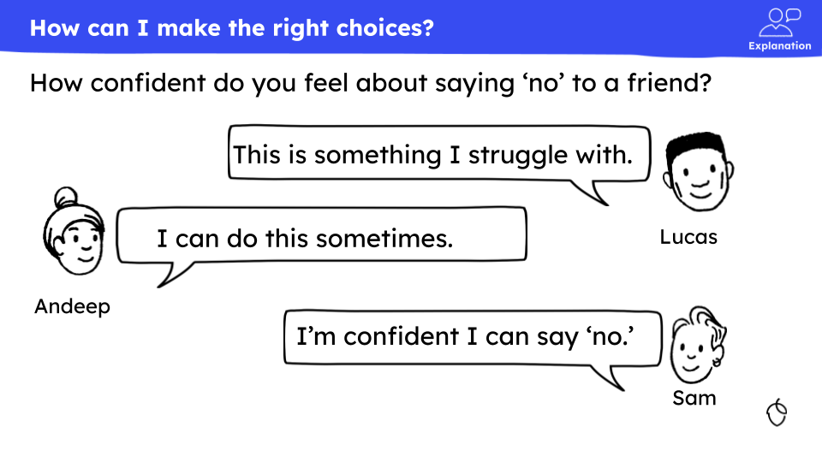  Oak created

Content guidance
Content guidance will be flagged in the CAT and will appear on the lesson pages of the website for teacher and pupils users.

- Content guidance and content guidance details should be included when necessary, for any sensitive content, potentially offensive content, health and safety or safeguarding risks related to the lesson.

- Where lesson content meets Oak’s safeguarding criteria for challenging content, it may only be used when it is essential to the lesson, and suitable content warnings have been included where appropriate.

EEF (2020)
Images from the nounproject

